ACSL
American Computer Science League
2007 - 2008

Contest #4

Intermediate Division
Trees

PROBLEM: Given an input string, create the binary search tree for the string using the rules provided in the ACSL description booklet.

INPUT: There will be 5 lines of input. Each line will contain a string of alpha characters, a positive integer, and the alpha character L or R.

OUTPUT: For each input line, print the left child (L) or the right child (R) of the character at the position in the string given by the positive integer. If none exists, then print NONE. Sample Input #1 directs you to print the left child of R, the first character in the string and Sample Input #2 directs you to print the right child of S, the sixth character in the string.

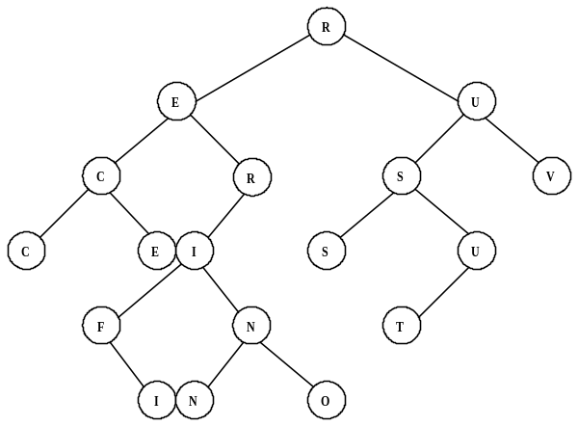

SAMPLE INPUT SAMPLE OUTPUT

1. RECURSIVEFUNCTIONS, 1, L 1. E

2. RECURSIVEFUNCTIONS, 6, R 2. U

3. RECURSIVEFUNCTIONS, 10, L 3. NONE
4. RECURSIVEFUNCTIONS, 15, R 4. NONE
4. RECURSIVEFUNCTIONS, 7, R 5. N

ACSL
American Computer Science League
2007 - 2008

Contest #4

Intermediate Division
Trees

TEST DATA

TEST INPUT TEST OUTPUT

1. BALTIMORE, 3, L 1. I
2. MARYLAND, 4, R 2. NONE
3. THIRTYYEARS, 9, L 3. NONE
4. MARRIOTTSRIDGE, 4, L 4. O
5. BINARYSEARCHTREE, 5, R 5. Y

